**Day 1 of remote sensing**

1. 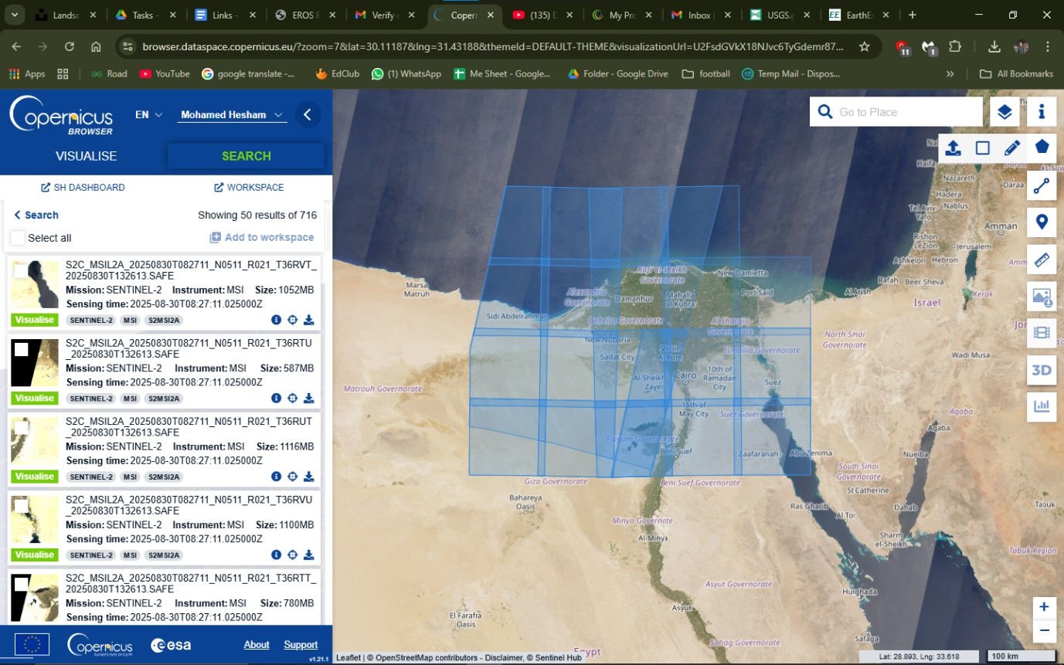**Sentinel** site
2. **Landsat** site

